Project Plan

|  |  |
| --- | --- |
| Student Name | Syukur Sidiq Nur Alam |
| Student ID | BDSE-0922-089 |
| Centre Name | Lithan EduClaas |
| Mentor | Arvinder Kaur |
| Date | 05/09/2023 |
| Qualification Name | Applied Degree in Software Engineering  Higher Diploma in Software Engineering |
| Milestone | Project Plan |
| Module Name (BDSE) | Capstone Project – Application Development |
| Project Title | Transforming Business Models in the Digital Era to Address Post-Covid Challenges. |

1. **Introduction**

The Covid-19 pandemic has brought unprecedented challenges to businesses worldwide, compelling them to adapt or risk obsolescence. In response, this plan outlines a strategic initiative to "Transform Business Models in the Digital Era to Address Post-Covid Challenges." It seeks to harness digital innovation to navigate the complex modern business landscape, fostering resilience and agility. This plan explores operational, economic, and strategic aspects, guiding organizations through the post-Covid digital era by embracing data-driven insights, emerging technologies, and innovation culture. While challenges abound, the promise of this transformative journey lies in seizing opportunities in an evolving digital landscape.

**2.0 Scope**

The scope of this project includes the following:

1. Implementation of a New Software System: The primary focus is on introducing and integrating a new software system into the existing infrastructure. This system will serve as a core element of the project, facilitating enhanced operational capabilities and efficiency.

2. Data Migration from the Old System to the New System: The project will involve the seamless transition of data from the current legacy system to the newly implemented software. Ensuring data integrity, accuracy, and completeness during migration is paramount.

3. User Training and Support: To facilitate a smooth transition and optimal utilization of the new software system, comprehensive training programs will be developed and delivered to end-users. Additionally, ongoing user support will be provided to address queries and issues that may arise during system operation.

4. System Maintenance and Upgrades: Continuous maintenance and periodic upgrades of the new software system are vital to its long-term functionality and relevance. This aspect of the project will ensure that the system remains up-to-date, secure, and aligned with evolving organizational needs.

**3.0 Objectives**

The objectives of this project are as follows:

1. To improve the accuracy and efficiency of the customer data management process: Transforming the business model in the digital era often involves leveraging advanced data management systems. Improved accuracy and efficiency in managing customer data align with the broader goal of digital transformation, as accurate and efficiently managed data is essential for making informed business decisions.

2. To increase the speed of customer data retrieval: In the digital era, quick access to customer data is crucial for providing personalized services, making timely decisions, and enhancing customer experiences. This objective aligns with the need for agility and responsiveness in the post-Covid digital landscape.

3. To reduce the time spent on manual data entry and management: Digital transformation often entails automating manual processes to increase efficiency. By reducing manual data entry and management, organizations can streamline operations, reduce errors, and allocate resources more effectively, all of which are essential in addressing post-Covid challenges.

4. To improve the quality of customer service provided to customers: Enhancing customer service quality is a fundamental aspect of digital transformation. Digital tools and systems can enable organizations to provide more responsive and tailored services to customers, thereby improving overall customer satisfaction.

**4.0 Milestones /WBS/Gant Chart**

The following milestones will be achieved during this project:

|  |  |  |
| --- | --- | --- |
| **Milestone** | **Target Date** | **Deliverable** |
| 1 | 1 September 2023 | completed reserch on customer experiene and made new design assumptions |
| 2 | 4 September 2023 | Create a feasibility docuent and objectives for the project |
| 3 | 5 September 2023 | Documment the comprehensive project plan detailing the project's objective, task, timeline, and responsibilities |
| 4 | 7 September 2023 | Implemementation of the new busniess models system |
| 5 | 16 September 2023 | Document sales promotions highlighting the benefits and business value of the dazling new model |
| 6 | 21 September 2023 | Completing applications testing, debugging, and making sure evertying is ready |

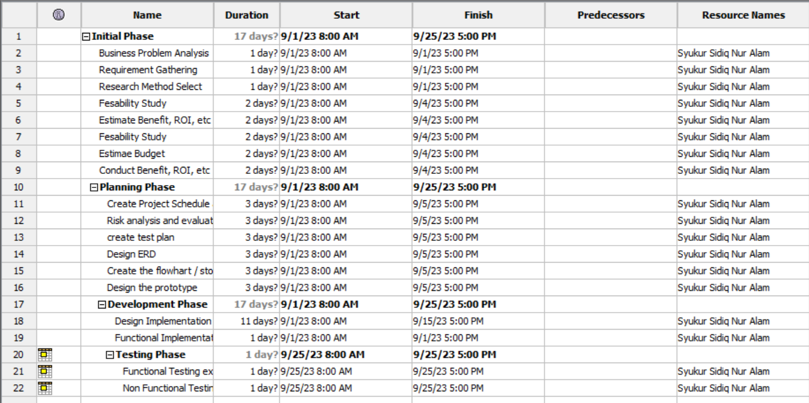

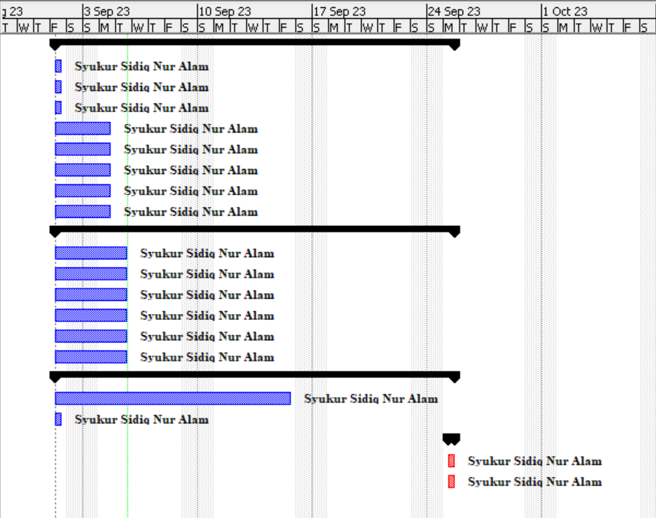

**5.0 Budget**

The following is the budget for this project:

|  |  |  |
| --- | --- | --- |
| **Item** | | **Budget** |
| **Software:** | * Windows 10 pro * WordPress Premium | $1.200 |
| **Hardware** | * Processor : Intel(R) Core(TM) i7-8550U CPU @ 1.80GHz 1.99 GHz * Memory : 32GB * Hard Drive : 4TB * SSD : 1TB NVMe Gen. 4 | $2.000 |
| **Training** | CMS WordPress, Elementor, WooCommerce, Database, DBMS. | $9550 |
| **Maintenance and upgrades** | Ongoing support, updates, bug fixes, and enhancements to ensure the system's functionality, security, and performance. | $3.100 |
| **Total** |  | $15.850 |

**6.0 Risk**

**Tabel UAT (User Acceptance Testing):**

| **No.** | **Risk** | **Impact** | **Likelihood** | **Mitigation Strategy** |
| --- | --- | --- | --- | --- |
| 1 | Payment System Failure | High | Medium | - Ensure compliance with payment security standards (e.g., PCI DSS) to protect customer payment data.  - Conduct periodic payment testing to identify issues.Provide various payment options for customers. |
| 2 | Customer Data Loss | High | Medium | - Perform regular data backups and maintain secure data copies in an off-site location.  - Utilize robust encryption technology to safeguard customer data. |
| 3 | Hosting Service Disruption | Medium | Medium | - Choose a reliable hosting service provider with responsive technical support.  - Develop a disaster recovery plan to address significant disruptions. |
| 4 | Payment Policy or Regulatory Changes | Medium | Low | - Monitor changes in payment policies or regulations related to e-commerce and adapt to the applicable policies. |
| 5 | Cybersecurity Breach | High | Medium | - Utilize intrusion detection systems (IDS) and web application firewall (WAF) to identify and prevent attacks.  - Conduct regular penetration testing to identify vulnerabilities. |
| 6 | Third-Party Service Disruption | Medium | Medium | - Assess the risk associated with dependency on third parties such as payment system providers or shipping services.  - Establish clear contractual agreements with third parties, including Service Level Agreements (SLAs) to ensure availability and quality of services. |

**Tabel Cross-Browsing Testing:**

| **No.** | **Browser** | **Test Scenario** | **Expected Result** | **Actual Result** | **Status** |
| --- | --- | --- | --- | --- | --- |
| 1 | Chrome | Login to the application | Successful login | Successful login | Pass |
| 2 | Firefox | Add a product to the shopping cart | Product is added to cart | Product is added to cart | Pass |
| 3 | Edge Microsoft | Checkout process | Smooth checkout process | Smooth checkout process | Pass |

**Tabel Performance Testing:**

| **No.** | **Test Scenario** | **Test Objective** | **Technique** | **Expected Result** | **Status** |
| --- | --- | --- | --- | --- | --- |
| 1 | Load Testing | Assess system under expected load | Using load testing tools | Response time within threshold, throughput as expected | Pass |
| 2 | Stress Testing | Evaluate system at peak load | Increasing user load beyond peak, generating high traffic | System should degrade gracefully without crashing | Pass |
| 3 | Scalability Testing | Test system's scalability | Incrementally increase user load | System should scale linearly with user load | Pass |

**Tabel Portability Testing:**

| **No.** | **Test Scenario** | **Test Objective** | **Technique** | **Expected Result** | **Status** |
| --- | --- | --- | --- | --- | --- |
| 1 | Operating System Compatibility Testing | Evaluate compatibility with various OS versions | Testing on different OS versions | Software functions without issues on tested OS versions | Pass |
| 2 | Mobile Device Compatibility Testing | Assess compatibility with mobile devices | Testing on different mobile devices | Software is responsive and usable on tested mobile devices | Pass |
| 3 | Browser Compatibility Testing | Ensure compatibility with various web browsers | Testing on different browsers | Website or web application displays and functions correctly on tested browsers | Pass |
| 4 | Database Compatibility Testing | Verify compatibility with different databases | Testing on different database systems | Software interacts with databases as expected on tested platforms | Pass |

**Database Design**

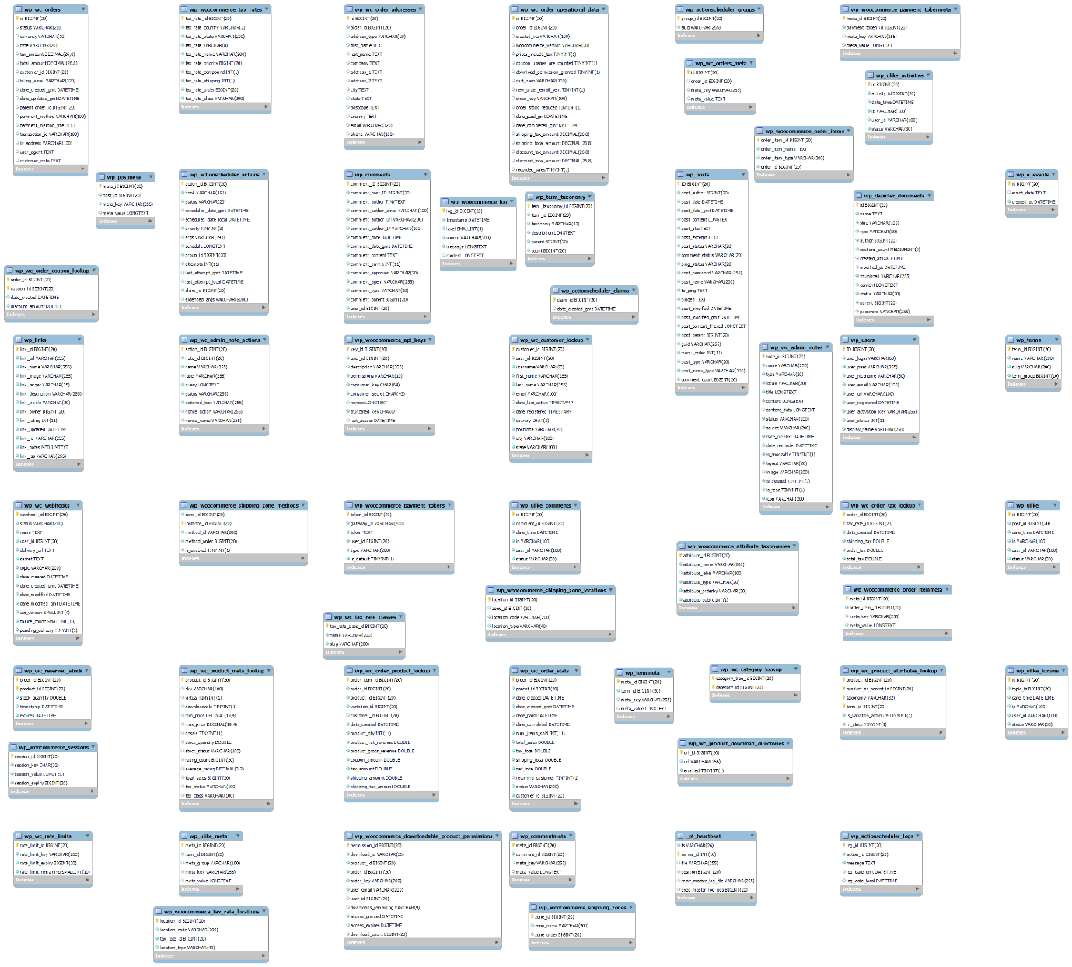

**Flow Chart**

